1. Write the Html to Produce the below code, attach a screenshot of the results as part of the answer. The table should be aligned to the centre of the page with a proportional width of 70% and a proportional height of 40%

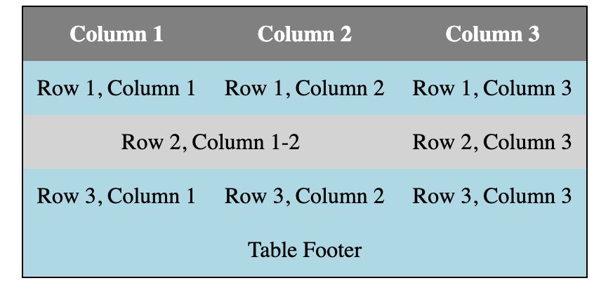

1. Write the Html to Produce the below code, attach a screenshot of the results as part of the answer. The table should be aligned to the centre of the page with a proportional width of 70% and a proportional height of 40%



1.  Write the Html to Produce the below code, attach a screenshot of the results as part of the answer. The table should be aligned to the centre of the page with a proportional width of 70% and a proportional height of 40%
2. 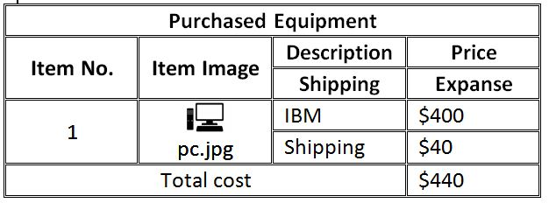 Write the Html to Produce the below code, attach a screenshot of the results as part of the answer. The table should be aligned to the centre of the page with a proportional width of 70% and a proportional height of 40%
3. Write the Html to Produce the below code, attach a screenshot of the results as part of the answer. The table should be aligned to the centre of the page with a proportional width of 70% and a proportional height of 40%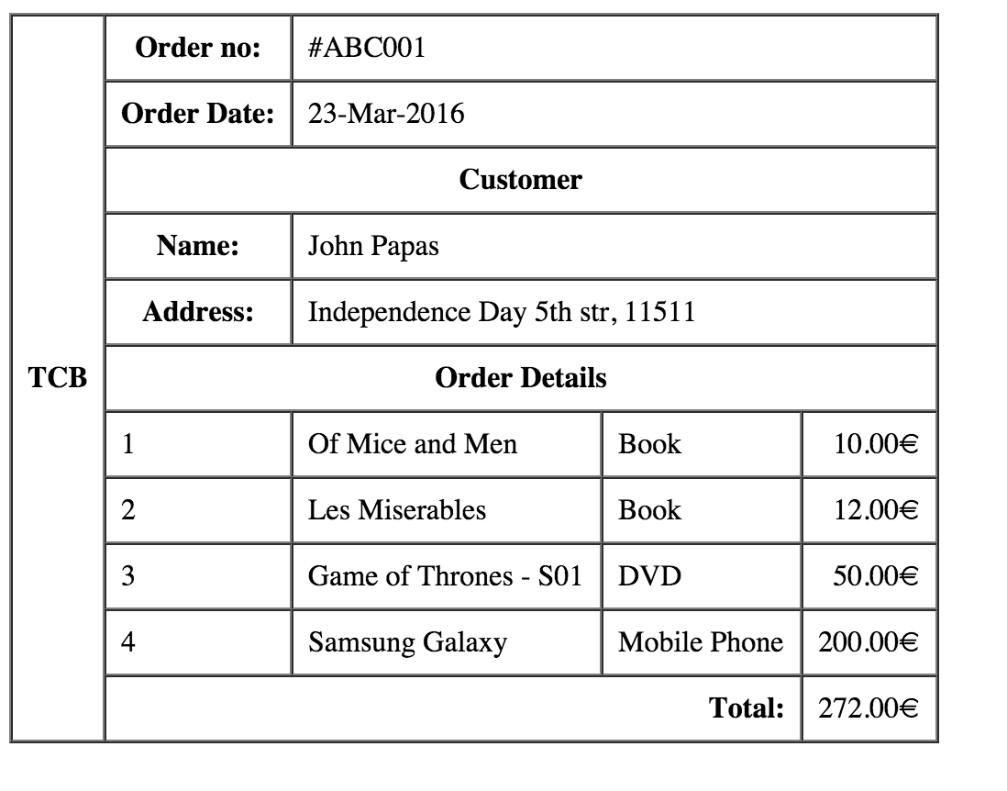
4. 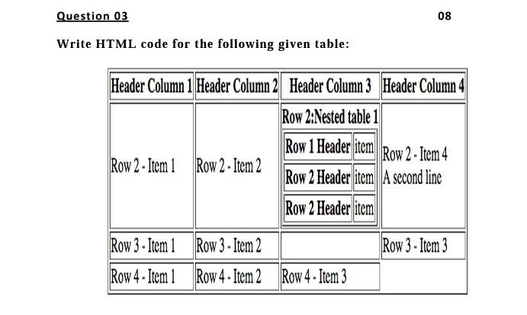Write the Html Code to produce the table below. Write the Html to Produce the below code, attach a screenshot of the results as part of the answer. The table should be aligned to the centre of the page with a proportional width of 70% and a proportional height of 40%
5. 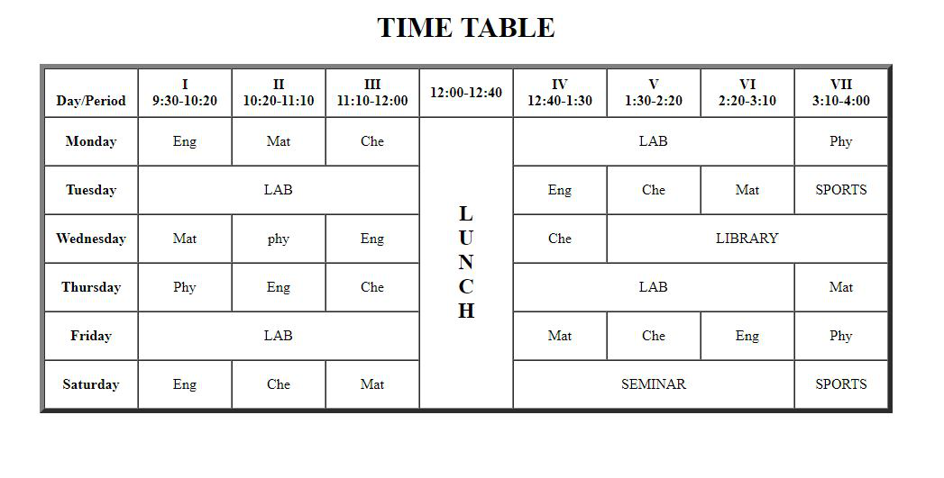Write the Html to Produce the below code, attach a screenshot of the results as part of the answer. The table should be aligned to the centre of the page with a proportional width of 70% and a proportional height of 40%
6. 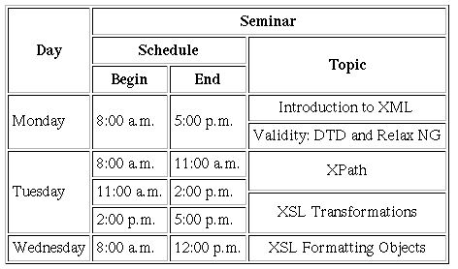Write the Html to Produce the below code, attach a screenshot of the results as part of the answer. The table should be aligned to the centre of the page with a proportional width of 70% and a proportional height of 40%

1. 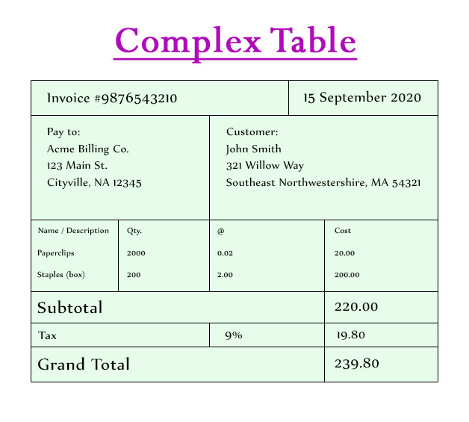Write the Html to Produce the below code, attach a screenshot of the results as part of the answer. The table should be aligned to the centre of the page with a proportional width of 70% and a proportional height of 40%
2. 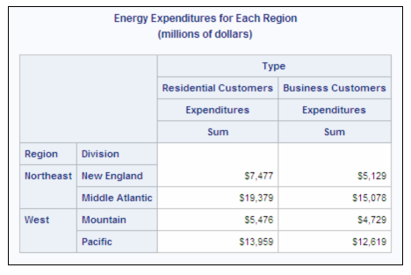Write the Html to Produce the below code, attach a screenshot of the results as part of the answer. The table should be aligned to the centre of the page with a proportional width of 70% and a proportional height of 40%

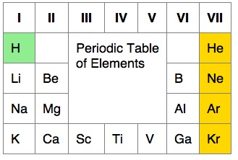  
11. Write the Html to Produce the below code, attach a screenshot of the results as part of the answer. The table should be aligned to the centre of the page with a proportional width of 70% and a proportional height of 40%

1. Write the Html to Produce the below code, attach a screenshot of the results as part of the answer. The table should be aligned to the centre of the page with a proportional width of 70% and a proportional height of 40%

